Used Car Price Prediction
with Machine Learning

Daniel Potapov
ITCS-3156-002
Final Project
04/27/2026

- Problem Introduction
- The Data
  - The Dataset

- Introduction
The used cars market is a huge and every growing market, where vehicles go from sellers to buyers all the time. Whenever you do purchase a used vehicle, or any vehicle in that matter, you know less than the seller selling you the car, this is just in the nature of how sales work. This gives the seller an advantage to either hide certain details, or up charge you on the vehicle even if the vehicle is not worth that price. Using machine learning, based on previously collected data, we can predict the actual price a vehicle should be worth, the fair value of the car. Using various machine learning techniques, we will predict on what the vehicles value is based on historic and physical features of the car to give the buyers an advantage when purchasing a new vehicle.

- The Data
  - The Dataset
For this problem we will be using Craigslist Vehicles Dataset found on Kraggle. This data set is a web scrape of historical car listing across the US from the Craigslist website, it has over 400,000 rows of different vehicles, and 26 columns of descriptions of those vehicles. The descriptions include: year, make, model, condition, odometer, price and some others. This data set was last updated 3 years ago, but this does not skew our final prediction model, since when you are purchasing a used car is most defiantly at least 3 years old or older.

  - Visualization
First we take a look at the general trends in the data, to see what we will be working with. We have used matlib and seaborn libraries to help me generate our graphs for this purpose. Firstly we take the price and odometer features to how they compare to each other. We create a scatter plot of the two features, sampling 20,000 columns, and see that there is a general downwards trend to the overall data. We see that there is a negative correlation between the milage and the price of the vehicle, the more the odometer shows the lower the price.

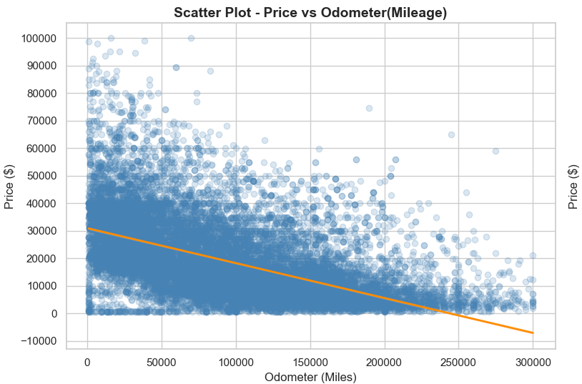
We can also take a heatmap of the same data and see the density of the dataset in regards to these two features. WE see that the most “hottest” point is around the 5,000 price mark and 150,000 milage mark, being the most common listing, this also shows us the same exact general downward curve that we saw in our scatter plot.
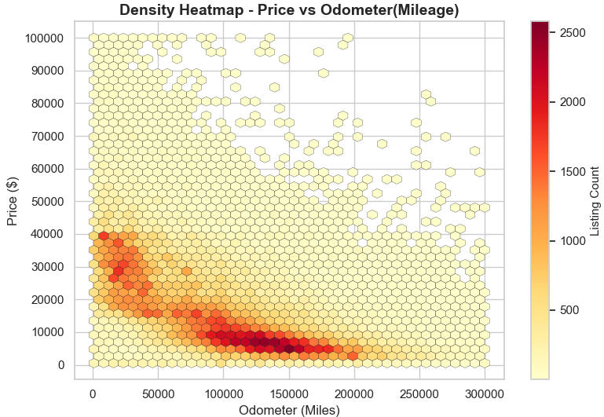
Next we took the comparison of the price vs year features, we created a scatter plot and a heat map of the two. In this case, the comparisons is the opposite of the odometer comparison, instead of a negative coloration, we see a positive coloration and trend upwards. The higher the year the more expensive the vehicle is. In the heat map, the most common listing by year turned out to be 2015, and at the 10,000 dollar price range.
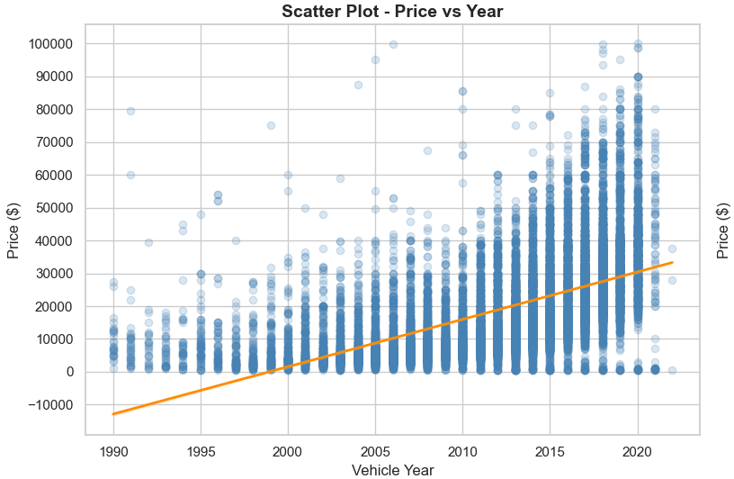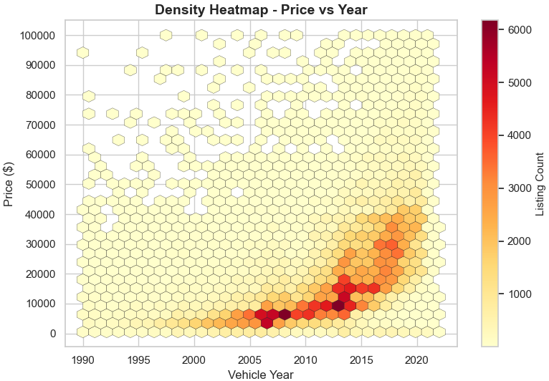
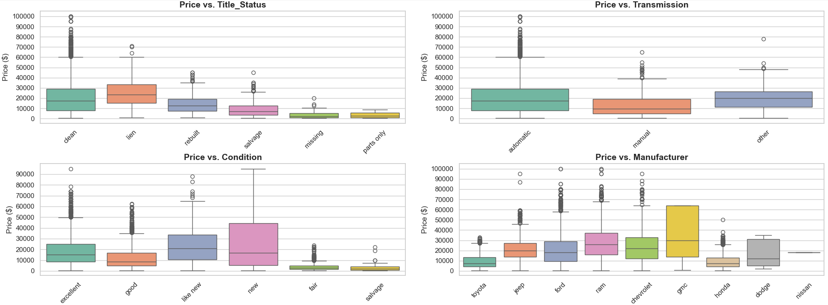
Lastly we look at the price when compared to the other features of the dataset. Here we can see a boxplot of the majority of the listings besides some outlier and the following features: title status, transmission type, condition, and manufacturer when compared to the price of the vehicle.
When analyzing the title status graph, we can see that clean title being the most popular, also has the largest spread of price, going all the way up to 100,000. At the same time, salvage, rebuild, and others are mostly squished in the cheaper price range with many being under 20,000. Transmission seems to not have too much a dramatic difference, but noticeable. Automatic transmissions are more common, but also reach to a more expensive price range, while manual transmissions are generally in the cheaper. Looking at the conditions box plot, we can see that there is a distinct difference in price range compared to condition. Excellent, good, new and like new conditions, generally meaning a good thing, drive the price higher and have a wider price spread. While the fair and salvage conditions are drastically cheaper falling no higher then some outliers at 20,000, keeping majority below the 10,000 dollar line. Lastly, looking at the manufacturer graph, majority of the prices remain in the same area of 10-40 thousand, but with some outliers, mainly in the Ram and Ford vehicles, GMC having a wide spread from about 15 to 65 thousand, meaning GMC vehicle are commonly resold. These graphs demonstrate that things like title status, manufacturer, and especially condition can drastically effect the final price of the vehicle you are trying to purchase

References:
Dataset:
mbaabu Harun Mwenda. “Craigslist Vehicles Dataset.” Kaggle.com, 2023, www.kaggle.com/datasets/mbaabuharun/craigslist-vehicles/data. Accessed 27 Apr. 2026.

